Department: | DENTAL & MAXILLOFACIAL DEPARTMENT

 | Name | Designation | Date | Signature
Prepared by | Dr. Yasir Rehman | Asst Prof | 07/04/2024 | 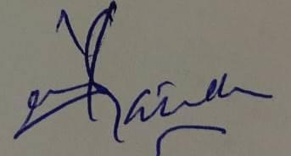
Reviewed by | Dr. Zahid Qayyum | Assoc Prof | 07/04/2025 | 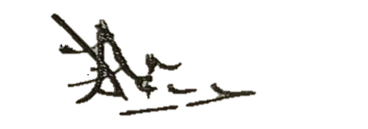
Approved by | Dr. Shehzad Akbar | Prof/MD | 07/04/2025 | 