JD No. | 09-DEN
Job Title | Junior Clerk
Department | HOD Concerned
Reporting To | Manager HR

Duties & Responsibilities | - To sort and handing out post.  - To assist in photocopying and scanning documents.  - To record and update databases.  - To assist filling of reports, documents and letters etc.  - To assist in projects of their managers.  - To maintain files and records so they remain updated and easily accessible.  - To utilize office appliances such as photocopier, printers etc. and computers for word processing, spreadsheet creation etc.  - To perform other office duties as assigned.  - To monitor stocks of office supplies (paper clips, stationary etc) and report when there are shortages.  - To assist in office management and organization procedures.  - To undertake basic bookkeeping tasks and issues invoices, checks etc.
Job Requirements / Hiring Criteria | Academic & Professional Qualifications:  - 01st Class Intermediate School Certificate from recognized Board.  - DIT from Technical Board or its equivalents.  - A Computer Typing speed 30 words Per Minute.
Job Requirements / Hiring Criteria | Related Experience:  - Relevant experience will be preferred.
Job Requirements / Hiring Criteria | Skills/Competencies:  - Basic administrative skills, including data entry, record-keeping, and filing, with proficiency in Microsoft Office, attention to detail, organizational abilities, and effective communication and customer service skills.
Working Environment | Working Conditions:  - Typically work in an office environment, sitting for long periods, with moderate noise levels, and minimal physical demands, requiring focus and concentration on tasks.
Working Environment | Physical Effort:  - Minimal physical effort, involving sitting, typing, and occasional walking, with rare lifting, bending, or stretching, and primarily engaging in mentally demanding tasks requiring concentration and attention to detail.

 | Name | Designation | Date | Signature
Prepared by | Dr. Yasir Rehman | Asst Prof | 07/04/2024 | 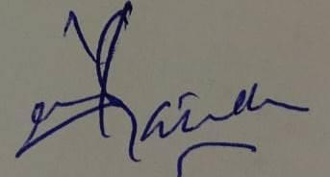
Reviewed by | Dr. Zahid Qayyum | Assoc Prof | 07/04/2025 | 
Approved by | Dr. Shehzad Akbar | Prof/MD | 07/04/2025 | 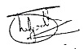

Acknowledgment:
I have read and understood my position description. I understand that these responsibilities maybe modified to meet arising needs in the department

Employee: | Date:

