JD No. | 08-DEN
Job Title | Clinical Technician Radiology
Department | Dental & Maxillofacial
Reporting To | HOD Dental & Maxillofacial

Job Overview | Operates and maintains dental X-ray equipment, positioning patients and capturing high-quality radiographs to aid in diagnosis and treatment planning.
Duties & Responsibilities | The radiographer will perform the following duties & any other duties assigned to him by the Radiologist or I/C of the unit to whom he is directly responsible  - Will perform his duties according to the duty roster & orders.  - Will maintain cleanliness & orderliness of the unit through other health workers.  - Will ensure that film is used before expiry date & keeps stock rotated so that oldest film is used first.  - Will maintain x-ray plant in perfect functioning condition. Clean & greases it & watches for problems.  - Will keep medico legal X rays film under lock & key & properly cared for.  - Will remain on call during off duty hours if unit is single handed.  - Will assist & cooperate with other health workers  - Will operate X ray machine as required by radiologist, MO I/C & provide X Rays therapy to patients under the supervision of the radiologist.  - Will adjust X ray machine to correct setting for each exposure. Positions & instruct patients & determines proper voltage & power supply required.  - Will arrange & adjust restrain & supportive devices (eg. Sand bags, binders, angle boards) to obtain the desired position of patients.  - Will adjust leads sheets to protect other parts of patients body from exposure to X rays.  - Will place exposed films & patients identification slip in to wall safe for processing by dark room attendant.  - Will wear protective clothing & will take all other safety precautions in performance of his duty.  - Will prepare & administer barium sulphate drinks to patients according to standard procedures required.  - Will give I/V injection of dye for special X-Rays under the supervision of the doctor on duty.  - Will put the developed films before radiologist for opinion & record the opinion on film cover.  - Will maintain stock register of films, equipment & machinery. Will keep film expense register, free register & daily attendance register up to date.  - Will maintain record of all receipts cash & their disbursement.  - Will collect used films & developing/fixing solutions for disposal or auction by competent authority.
Job Requirements / Hiring Criteria | Academic & Professional Qualifications:  - Diploma or certificate in X-Ray Technology  - Registered with the Khyber Pakhtunkhwa Paramedical Council (KPPMC)  - Strong hand-eye coordination and manual dexterity  - Ability to work accurately and efficiently
Job Requirements / Hiring Criteria | Related Experience:  - 5 years relevant experience
Job Requirements / Hiring Criteria | Skills/Competencies:  - Requires skills in patient positioning, radiation safety, equipment operation, image acquisition and quality control, and patient care, with attention to detail and strong communication skills.
Working Environment | Working Conditions:  - Exposed to ionizing radiation, with frequent standing, walking, and lifting, in a high-stress environment with variable shifts and patient contact.
Working Environment | Physical Effort:  - Require moderate to heavy physical effort, involving standing, walking, lifting, and positioning patients and equipment, with frequent bending and stretching.

 | Name | Designation | Date | Signature
Prepared by | Dr. Yasir Rehman | Asst Prof | 07/04/2024 | 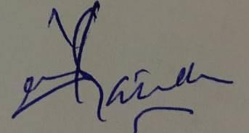
Reviewed by | Dr. Zahid Qayyum | Assoc Prof | 07/04/2025 | 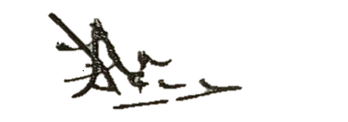
Approved by | Dr. Shehzad Akbar | Prof/MD | 07/04/2025 | 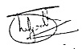

Acknowledgment:
I have read and understood my position description. I understand that these responsibilities maybe modified to meet arising needs in the department

Employee: | Date:

