JD No. | 04-DEN
Job Title | Dental Surgeon
Department | Dentistry & Maxillofacial
Reporting To | HOD Dentistry & Maxillofacial

Job Overview | Dental surgeon job is to diagnose and treat various dental conditions, and contribute to the growth and development of dental department.
Duties & Responsibilities | - To perform surgeries such as tooth extractions and reconstructive surgery, perform root canals and other procedures pertaining to the inside of teeth, and treat gum related diseases.  - To write prescriptions for antibiotics or other medications.  - To examine x- rays of teeth, gums, the jaw, and nearby areas for problems.  - To make models and measurements for dental appliances, such as dentures, to fit patients.  - To teach patients about diet, flossing, use of fluoride, and other aspects of dental care.  - To clean and repair teeth, extracting teeth when necessary, fitting crowns and administering anesthesia prior to dental procedures.  - To lead dental staff in patient care.
Job Requirements / Hiring Criteria | Academic & Professional Qualifications:  - MBBS/BDS or equivalent from recognized University or equivalent qualification.  - Recognized by PM&DC/PMC.
Job Requirements / Hiring Criteria | Related Experience:  - Relevant experience will be preferred.
Job Requirements / Hiring Criteria | Skills/Competencies:  - Registered with the Pakistan Medical and Dental Council (PMDC).  - Relevant clinical experience, preferably in a hospital setting.  - Strong communication and interpersonal skills.
Working Environment | Working Conditions:  - Ability to work effectively in a team environment.
Working Environment | Physical Effort:  - Climate-controlled clinic with comfortable temperatures and humidity levels.  - Well-lit and ventilated workspace.  - Ergonomic chairs and equipment to reduce strain and discomfort.

 | Name | Designation | Date | Signature
Prepared by | Dr. Yasir Rehman | Asst Prof | 07/04/2024 | 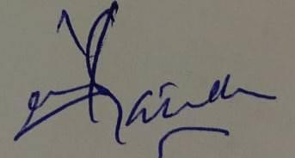
Reviewed by | Dr. Zahid Qayyum | Assoc Prof | 07/04/2025 | 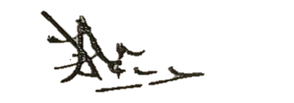
Approved by | Dr. Shehzad Akbar | Prof/MD | 07/04/2025 | 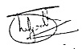

Acknowledgment:
I have read and understood my position description. I understand that these responsibilities maybe modified to meet arising needs in the department

Employee: | Date:

