A
Department: | Public Relation Office

 | Name | Designation | Date | Signature
Prepared by | Ishrat | PRO |  | 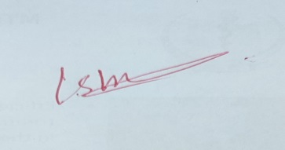
Reviewed by |  | RMO
Approved by | Shehzad Akbar | HD |  | 