JD No. | 01-PRO
Job Title | Public Relations Officer
Department | PRO
Reporting To | RMO

Job Overview | Assist media cell in developing good image of the institute and liaison for better PR of the hospital management
Duties & Responsibilities | - Arranging PR events and activities  - Liaising with and answering enquiries from media, individuals and other organizations, often via telephone, email and other sources.  - Assist and coordinate with stakeholders and public.  - Collating and analyzing media coverage.  - Devising and coordinating PR opportunities.  - Prepare contents for social media pages of the hospital.  - Managing the PR aspect of a potential crisis situation.  - Maintain a record of the media coverage related to hospital.  - Liaison with hospital management and media cell for issues and challenges.  - Prepare, maintain and Disseminate PR kit.  - Any other responsibility/job assigned by the supervisor.
Job Requirements / Hiring Criteria | Academic & Professional Qualifications:  - University degree from a recognized university.
Job Requirements / Hiring Criteria | Related Experience:
Job Requirements / Hiring Criteria | Skills/Competencies:  - The candidate must possess strong PR, communication skills.  - Good relations with the media, ability to handle and resolve conflict/ problematic situations.  - Excellent writing skills, excellent negotiation skills and ability to close a deal.  - Ability to prepare media plans/budgets and to monitor expenditure against budgets, excellent creative writing skills, ability to write, proof read media content effectively.  - Ability to build relationships at all levels, ability to work autonomously and as a member of a team.
Working Environment | Working Conditions:  - Work in office related environment.
Working Environment | Physical Effort:  - Any task related to department inside hospital.

 | Name | Designation | Date | Signature
Prepared by | Ishrat | PRO |  | 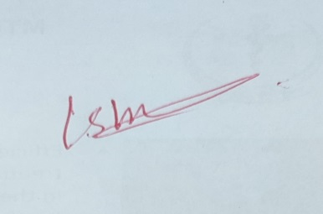
Reviewed by |  | RMO
Approved by | Shehzad Akbar | Hospital Director |  | 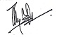

Acknowledgment:
I have read and understood my position description. I understand that these responsibilities maybe modified to meet arising needs in the department

Employee: | Date:

